**TABLE OF CONTENTS**

**Contents**

LIST OF FIGURES 3

ABSTRACT 5

KEYWORDS: 5

CHAPTER 1 6

INTRODUCTION TO PROJECT 6

Project Aim and Objective 6

Problem Statement 7

Software Requirements 7

Hardware Requirements 7

CHAPTER 2 8

PRODUCT BACKLOG 8-9

Sprint  Backlog-1 10-11

Sprint Backlog-2 12-14

Sprint Backlog-3 15-16

Sprint Backlog-4 17-18

CHAPTER 3 19

TECHNOLOGY APPLIED AND PROJECT MANAGEMENT 19

Project Management : 19

Software Project Management 19-20

Software Project 20

Need of software project management 20-21

Software Project Manager 21

Software Management Activities 22

Project Planning 22

Scope Management 22

Project Estimation 23

Project Estimation Techniques 24

Decomposition Technique 24

Empirical Estimation Technique 24-25

Project Scheduling 25

Resource Management 25

Project Risk Management 26

Risk Management Process 26

Project Execution & Monitoring 27

Project Communication Management 27-28

Configuration Management 28

Project Management Tools: 28

01. Trello 28-29

02. Basecamp 29

03. Teamwork Projects 29

04. Resource Guru 29

05. ActiveCollab 29

06. Zoho Projects 30

07. Jira 30

08. Asana 30

09. Podio 30

10. Freedcamp 30

11. Wrike 31

PO and Their Relevance to project 31-34

CHAPTER 4 35

PROJECT IMPLEMENTATION 35

Sprint Backlog-1 35-40

Sprint Backlog-2 41-45

Sprint Backlog-3 46-48

Sprint Backlog-4 49-51

CHAPTER 5 51

CONCLUSION 51

Results 51

Conclusion 51

Future Scope 51

# LIST OF FIGURES

|  |  |  |
| --- | --- | --- |
| Figure 1 | Product Backlog (Part-I) | 8 |
| Figure 2 | Product Backlog {Part-II) | 9 |
| Figure 3 | Sprint Backlog 1 | 11 |
| Figure 4 | Burnt Down Chart 1 | 12 |
| Figure 5 | Sprint Backlog 2 (Part-I) | 13 |
| Figure 6 | Sprint Backlog 2 (Part-II) | 14 |
| Figure 7 | Sprint Backlog 2 (Part-III) | 14 |
| Figure 8 | Burnt Down Chart 2 | 15 |
| Figure 9 | Sprint Backlog 3 | 16 |
| Figure 10 | Burnt Down Chart 3 | 17 |
| Figure 11 | Sprint Backlog 4 (Part-I) | 18 |
| Figure 12 | Sprint Backlog 4 (Part-II) | 19 |
| Figure 13 | Burnt Down Chart 4 | 19 |
| Figure 14 | Triple Constraints | 22 |
| Figure 15 | Home_1 | 38 |
| Figure 16 | Home_2 | 38 |
| Figure 17 | Login | 39 |
| Figure 18 | Sign up | 39 |
| Figure 19 | Contact Form | 40 |
| Figure 20 | Database | 40 |
| Figure 21 | Signup Table | 41 |
| Figure 22 | Login Front end | 41 |
| Figure 23 | Login Backend | 42 |
| Figure 24 | Signup Frontend | 42 |
| Figure 25 | Signup Backend | 43 |
| Figure 26 | Create Resume | 43 |
| Figure 27 | Services | 44 |
| Figure 28 | Personal Info | 44 |
| Figure 29 | Educational Info | 45 |
| Figure 30 | Project Info | 45 |
| Figure 31 | Others_info Table | 46 |
| Figure 32 | Educational_info Table | 46 |
| Figure 33 | Others_info Frontend | 47 |
| Figure 34 | Educational_info Frontend | 47 |
| Figure 35 | Other Details | 48 |
| Figure 36 | Technical Details | 48 |
| Figure 37 | Project_info Table | 49 |
| Figure 38 | Technical Table | 49 |
| Figure 39 | Technical Frontend | 50 |
| Figure 40 | Others Frontend | 50 |
| Figure 41 | Home Slider | 51 |
| Figure 42 | Contact Button | 51 |
| Figure 43 | Ready | 52 |
| Figure 44 | Ready_code | 52 |
| Figure 45 | Resume | 53 |

# ABSTRACT:

A resume is a document that contains the details of a job seeker or listing of relevant job experience and education.The resume is the most important document for any individual or job seeker when they apply for a job. It is basically the first impression of a candidate on the interviewer and we know that first impression is the last impression. A well-written and well-designed resume is essential in a job search process. Resume builder is a website which simplifies your work by creating a resume. It becomes very difficult to decide that what are the things to put on resume and what's not. Resume builder makes your resume in a user-friendly and easy format. You can add different sections like Biographical Data, Objective, Employment History, Education History, Personal, and Skill areas, Publications, Summary and Certifications.

# KEYWORDS:

Resume, Resume templates, Summary, Certificates, Skills, Qualifications.

# CHAPTER 1

# INTRODUCTION TO PROJECT

**Project Aim and Objective:**

* The aim of the project is to develop an online website with the help of which a user can create his/her resume without a hassle.
* Resume plays an important role in grabbing the perfect job or the dream job and if you have worked so hard in your life for this one chance you need to be fully prepared and the first thing that will help you get that job is a resume and the user can create one with the help of our website
* Resume attracts the Interviewer most it’s like first impression of the candidate and the candidate can create that with a perfect resume as resume contains all the information he has done from the time of born to now.
* It contain what are the skills that the candidate possess whether it’s a soft skill or a technical skill.
* Resume gives a brief idea about one’s personality and it will also a help for the interviewer to judge whether the candidate is suitable for their job or not.
* An online resume builder is a software developed to simplify the task of creating a resume for individuals.
* The application provides an effective means of designing desired resume in fact a professional looking resume.
* As the resume templates are already available it reduces the need of user thinking and designing an appropriate resume according to his/her resume.
* The biggest use of our project is for the students who just completed their graduates and looking for the jobs as they are confused about what are the things they should put onto a resume. So to help them the system is developed in such a way that that they can create their resume like a professional looking resume.
* This project is made to reduce human intervention and it is user-friendly also.
* An individual just need to fill up different sections under a form such as personal information, educational information, qualities, interest, skills, etc.
* After filling the form, the data is stored and then system generates the well-structured resume.

**Features:**

* **Admin login:** Admin has the rights to can see who administers the system and input updates.
* **User login:** To access to our website the user need to create an account, once the account is verified. The user can log in with the same credentials that he/she has used during the time of Signup.
* **Resume templates:** Every user wants different type of user. So to do that various templates are available in the system with the help of which user can choose the available resume templates and can make their resume easily.
* **Resume form:** Once the user is done with selecting the resume template, they will get the form on which they have to fill their information.
* **Resume builder:** After fulfilling all the information the user can submit the information and BOOM your resume is ready.
* **Choice of file:** User can download their resume in pdf format only.

## Problem Statement:

## When a candidate applies for a job, the most important thing that will help him/her to grab that job is resume. Some of the candidates are fresher who don’t know how to build their resume and most of the candidate lacks there and not able to grab the job. So all the candidates who don’t have good resume building skills, don’t need to worry because our project will help them to build the perfect resume and able to get the job they want.

## Software Requirements:

* Visual Studio.
* Microsoft SQL Server.
* Windows 7 and above.

## Hardware Requirements:

* Hard Disk – 5 GB
* Memory – 1GB RAM
* Processor – i3.

# CHAPTER 2

# PRODUCT BACKLOG

## Product Backlog:

## Product backlog is the main log which contains all the details of the tasks which is going to be implemented in this project. The product backlog is basically the schema of all the task. The product backlog is then divided into 4 parts which is known as Sprint backlogs. It contains various fields such as SPRINT BACKLOG NUMBER, USID, BACKLOG ITEM, ESTIMATE DATE, REMARKS.

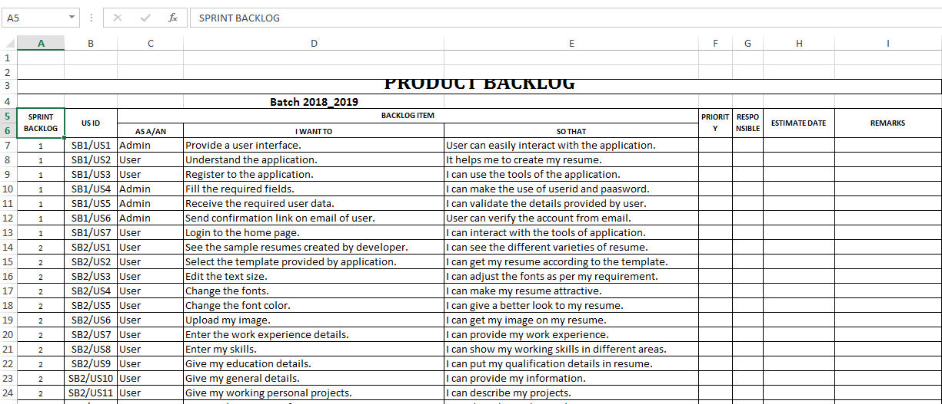

**Figure 1 Product Backlog-I**

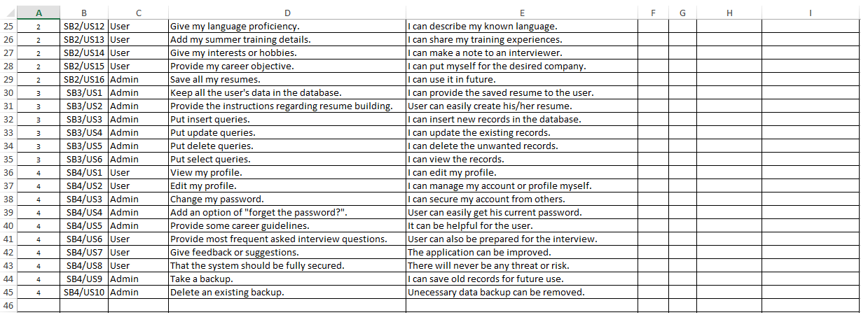

**Figure 2 Product Backlog-II**

## 

## Sprint Backlog-1:

## Talking about the Sprint Backlog 1, the user stories are sequenced in such a way to create design of User Interface For the end user interaction and completing the basic website requirements for user data inputs so that user can access in its personal session and can improve personal experience with the front-end look of the website and also use the functionality. In this portion of the development, we are also implementing the database as well as various tables for the Resume Builder. On behalf of the backend, we have created the attractive Signup and Login form so that the user can enter into its session. For designing part we have also implemented Bootstrap and Cascading Style Sheets to the different pages of our project and so beautify the webpages for good user experience. For the secure and valid data input, we have also implemented validation to the various areas of pages like email, password etc. Also, the linking of Home Page to the Login/Index Page is done for the secure session. In the validation part, all the input values by the user will be checked from the database to confirm its validity.

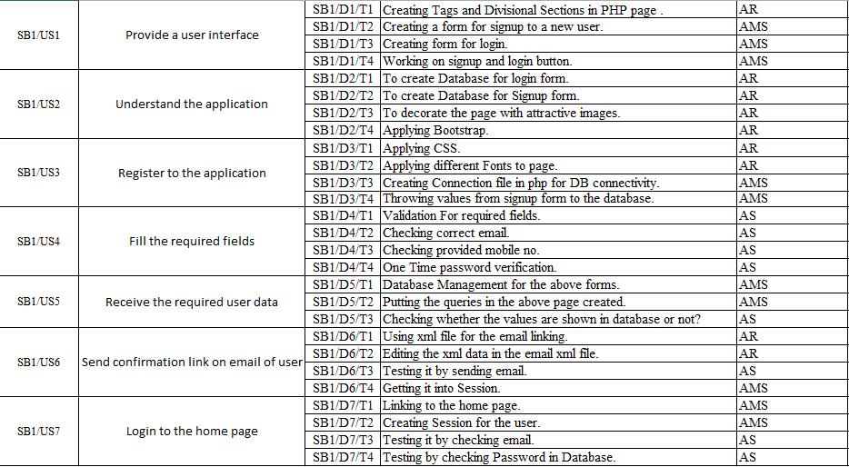**Figure 3 Sprint Backlog 1**

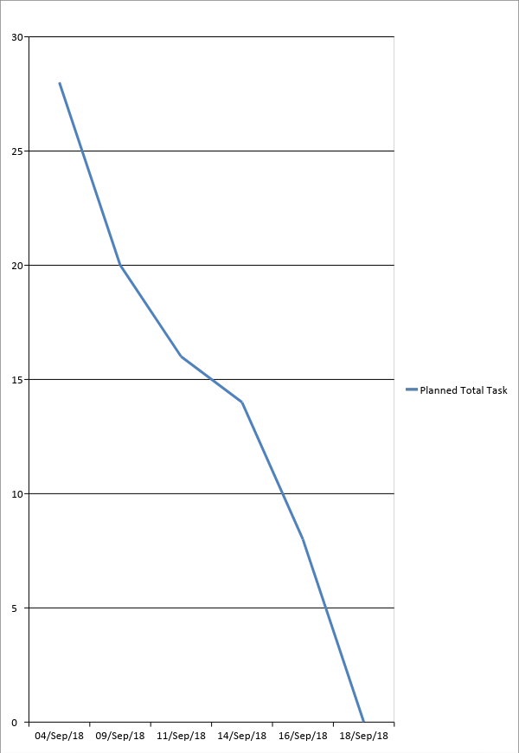

**Figure 4 Burnt Down Chart 1**

## Sprint Backlog-2:

The user is able to see the resume which is already present in the application. Once the user selected a particular template then they have to feed their information in it. Once they are done with choosing the template, they can see their customizable resume form to be filled by them personally.In this template, the user can change the size type and properties of Font-Family depending on the user choices.In this, we also provide the user to change font color and upload as well as set the User Profile Image. The User can also see the famous resumes suggested by the top 10 resumes on the Internet to make a difference in creating the resume.

## C:\Users\Abhinav Sharma\Documents\PPT\SB2-1.PNG

## Figure 5 Sprint Backlog 2 (Part I)

## C:\Users\Abhinav Sharma\Documents\PPT\SB2-2.PNG

## Figure 6 Sprint Backlog 2 (Part-II)

## C:\Users\Abhinav Sharma\Documents\PPT\SB2-3.PNG

**Figure 7 Sprint Backlog 2 (Part-III)**

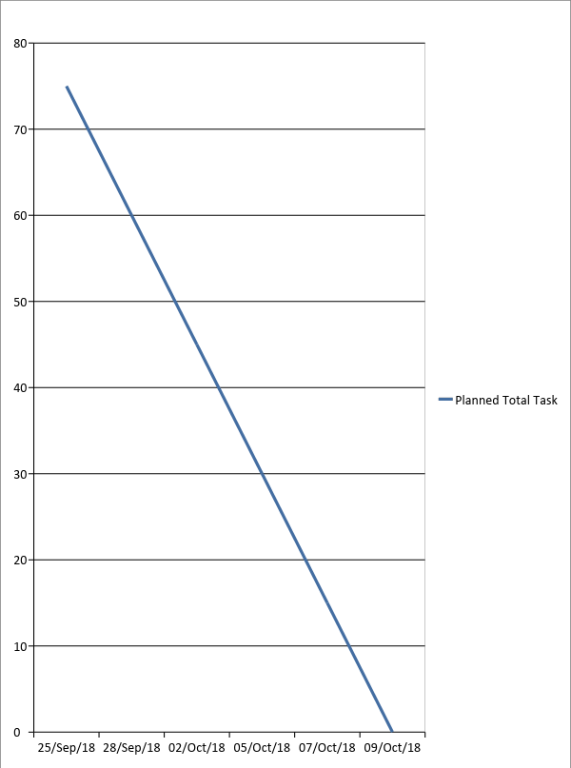

## Figure 8 Burnt Down Chart 2

## Sprint Backlog-3

Talking about the Sprint Backlog 3, this portion of project development includes the implementation of Graphic User Interface (GUI). In this Sprint Backlog, we are just making the Server to Client connectivity to check the validation from server level as well as client level. In this part, we have also included the web page having instructions to create the resume as the resume is for the freshers. This page also includes the attractive design for a better understanding of an End-User. It also provides the search operation for the user to search relevant data according to its resume as the search queries are implemented in the database tables. The user can also search the relevant blogs suggested by the website for better results in creating a resume. And so that this portion of our project covers the 75% of our website.

## C:\Users\Abhinav Sharma\Documents\PPT\SB3.PNG

## Figure 9 Sprint Backlog 3

## C:\Users\Abhinav Sharma\Documents\PPT\SB-3 Chart.PNG

## Figure 10 Burnt Down Chart 3

\

## 

## Sprint Backlog-4

Once the user is successfully logged in, he/she can see their profile and can change their password. In case, when the user forgot their password then they don’t need to worry they can change their password as we have provided an option of “Forgot your password”.

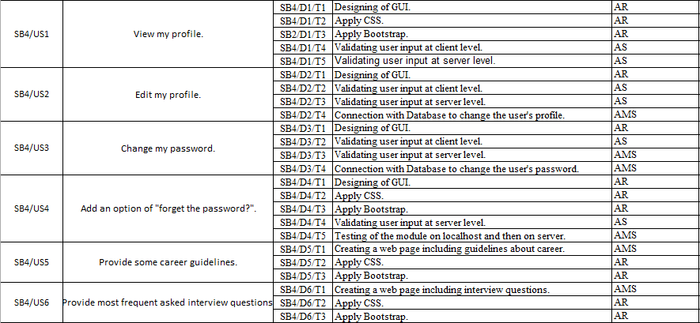**Figure 11 Sprint Backlog 4 (Part-I)**

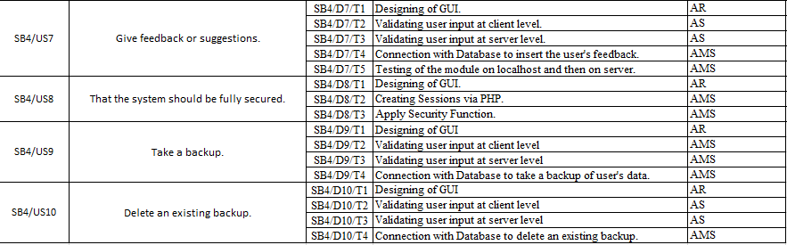

**Figure 12 Sprint Backlog 4 (Part-II)**

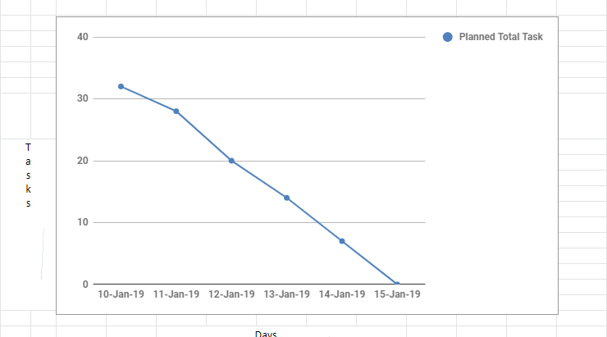

**Figure 13 Burnt Down Chart 4**

# 

# CHAPTER 3

# TECHNOLOGY APPLIED AND PROJECT MANAGEMENT

## Project Management :

Project management is the application of processes, methods, knowledge, skills and experience to achieve the project objectives. General. A project is a unique, transient endeavor, undertaken to achieve planned objectives, which could be defined in terms of outputs, outcomes or benefits.

Project management is the practise of initiating, planning, executing, controlling, and closing the [work](https://en.wikipedia.org/wiki/Work_(project_management)) of a [team](https://en.wikipedia.org/wiki/Project_team) to achieve specific goals and meet specific success criteria at the specified time. A [project](https://en.wikipedia.org/wiki/Project) is a temporary endeavor designed to produce a unique product, service or result with a defined beginning and end undertaken to meet unique goals and objectives, typically to bring about beneficial change or added value. The temporary nature of projects stands in contrast with [business as usual](https://en.wikipedia.org/wiki/Business_operations), which are repetitive, permanent, or semi-permanent functional activities to produce products or services. In practice, the [management](https://en.wikipedia.org/wiki/Management) of such distinct production approaches requires the development of distinct technical skills and management strategies.

## Software Project Management

Software project management is the art and science of planning and leading software projects. It is a sub-discipline of [project management](https://en.wikipedia.org/wiki/Project_management) in which [software](https://en.wikipedia.org/wiki/Software) projects are planned, implemented, monitored and controlled.

The job pattern of an IT company engaged in software development can be seen split in two parts:

* Software Creation
* Software Project Management

A project is well-defined task, which is a collection of several operations done in order to achieve a goal (for example, software development and delivery). A Project can be characterized as:

* Every project may have a unique and distinct goal.
* Project is not routine activity or day-to-day operations.
* Project comes with a start time and end time.
* Project ends when its goal is achieved hence it is a temporary phase in the lifetime of an organization.
* Project needs adequate resources in terms of time, manpower, finance, material and knowledge-bank.

## Software Project

A Software Project is the complete procedure of software development from requirement gathering to testing and maintenance, carried out according to the execution methodologies, in a specified period of time to achieve intended software product.

## Need of software project management

Software is said to be an intangible product. Software development is a kind of all new stream in world business and there’s very little experience in building software products. Most software products are tailor made to fit client’s requirements. The most important is that the underlying technology changes and advances so frequently and rapidly that experience of one product may not be applied to the other one. All such business and environmental constraints bring risk in software development hence it is essential to manage software projects efficiently.

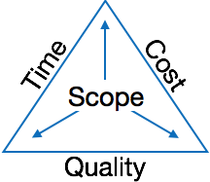

**Figure 14 Triple Constraints**

The image above shows triple constraints for software projects. It is an essential part of software organization to deliver quality product, keeping the cost within client’s budget constraint and deliver the project as per scheduled. There are several factors, both internal and external, which may impact this triple constraint triangle. Any of three factor can severely impact the other two.

Therefore, software project management is essential to incorporate user requirements along with budget and time constraints.

## Software Project Manager

A software project manager is a person who undertakes the responsibility of executing the software project. Software project manager is thoroughly aware of all the phases of SDLC that the software would go through. Project manager may never directly involved in producing the end product but he controls and manages the activities involved in production.

A project manager closely monitors the development process, prepares and executes various plans, arranges necessary and adequate resources, maintains communication among all team members in order to address issues of cost, budget, resources, time, quality and customer satisfaction.

Let us see few responsibilities that a project manager shoulders -

**Managing People**

* Act as project leader
* Liaison with stakeholders
* Managing human resources
* Setting up reporting hierarchy etc.

**Managing Project**

* Defining and setting up project scope
* Managing project management activities
* Monitoring progress and performance
* Risk analysis at every phase
* Take necessary step to avoid or come out of problems
* Act as project spokesperson

## Software Management Activities

Software project management comprises of a number of activities, which contains planning of project, deciding scope of software product, estimation of cost in various terms, scheduling of tasks and events, and resource management. Project management activities may include:

* **Project Planning**
* **Scope Management**
* **Project Estimation**

## Project Planning

Software project planning is task, which is performed before the production of software actually starts. It is there for the software production but involves no concrete activity that has any direction connection with software production; rather it is a set of multiple processes, which facilitates software production. Project planning may include the following:

## Scope Management

It defines the scope of project; this includes all the activities, process need to be done in order to make a deliverable software product. Scope management is essential because it creates boundaries of the project by clearly defining what would be done in the project and what would not be done. This makes project to contain limited and quantifiable tasks, which can easily be documented and in turn avoids cost and time overrun.

During Project Scope management, it is necessary to -

* Define the scope
* Decide its verification and control
* Divide the project into various smaller parts for ease of management.
* Verify the scope
* Control the scope by incorporating changes to the scope

## Project Estimation

For an effective management accurate estimation of various measures is a must. With correct estimation managers can manage and control the project more efficiently and effectively.

Project estimation may involve the following:

* **Software size estimation**

Software size may be estimated either in terms of KLOC (Kilo Line of Code) or by calculating number of function points in the software. Lines of code depend upon coding practices and Function points vary according to the user or software requirement.

* **Effort estimation**

The managers estimate efforts in terms of personnel requirement and man-hour required to produce the software. For effort estimation software size should be known. This can either be derived by managers’ experience, organization’s historical data or software size can be converted into efforts by using some standard formulae.

* **Time estimation**

Once size and efforts are estimated, the time required to produce the software can be estimated. An effort required is segregated into sub categories as per the requirement specifications and interdependency of various components of software. Software tasks are divided into smaller tasks, activities or events by Work Breakthrough Structure (WBS). The tasks are scheduled on day-to-day basis or in calendar months.

The sum of time required to complete all tasks in hours or days is the total time invested to complete the project.

* **Cost estimation**

This might be considered as the most difficult of all because it depends on more elements than any of the previous ones. For estimating project cost, it is required to consider -

* + Size of software
  + Software quality
  + Hardware
  + Additional software or tools, licenses etc.
  + Skilled personnel with task-specific skills
  + Travel involved
  + Communication
  + Training and support

## Project Estimation Techniques

We discussed various parameters involving project estimation such as size, effort, time and cost.Project manager can estimate the listed factors using two broadly recognized techniques

## Decomposition Technique

This technique assumes the software as a product of various compositions.

There are two main models -

* **Line of Code** Estimation is done on behalf of number of line of codes in the software product.
* **Function Points** Estimation is done on behalf of number of function points in the software product.

## Empirical Estimation Technique

This technique uses empirically derived formulae to make estimation. These formulae are based on LOC or FPs.

* **Putnam Model**

This model is made by Lawrence H. Putnam, which is based on Norden’s frequency distribution (Rayleigh curve). Putnam model maps time and efforts required with software size.

* **COCOMO**

COCOMO stands for COnstructive COst MOdel, developed by Barry W. Boehm. It divides the software product into three categories of software: organic, semi-detached and embedded.

## Project Scheduling

Project Scheduling in a project refers to roadmap of all activities to be done with specified order and within time slot allotted to each activity. Project managers tend to define various tasks, and project milestones and they arrange them keeping various factors in mind. They look for tasks lie in critical path in the schedule, which are necessary to complete in specific manner and strictly within the time allocated. Arrangement of tasks which lies out of critical path are less likely to impact overall schedule of the project.

For scheduling a project, it is necessary to -

* Break down the project tasks into smaller, manageable form
* Find out various tasks and correlate them
* Estimate time frame required for each task
* Divide time into work-units
* Assign adequate number of work-units for each task
* Calculate total time required for the project from start to finish

**Resource Management**

All elements used to develop a software product may be assumed as resource for that project. This may include human resource, productive tools and software libraries.

The resources are available in limited quantity and stay in the organization as a pool of assets. The shortage of resources hampers the development of project and it can lag behind the schedule. Allocating extra resources increases development cost in the end. It is therefore necessary to estimate and allocate adequate resources for the project.

Resource management includes -

* Defining proper organization project by creating a project team and allocating responsibilities to each team member
* Determining resources required at a particular stage and their availability
* Manage Resources by generating resource request when they are required and de-allocating them when they are no more needed.

## Project Risk Management

Risk management involves all activities pertaining to identification, analysing and making provision for predictable and unpredictable risks in the project. Risk may include the following:

* Experienced staff leaving the project and new staff coming in.
* Change in organizational management.
* Requirement change or misinterpreting requirement.
* Under-estimation of required time and resources.
* Technological changes, environmental changes, business competition.

## Risk Management Process

There are following activities involved in risk management process:

* **Identification -** Make note of all possible risks, which may occur in the project.
* **Categorize -** Categorize known risks into high, medium and low risk intensity as per their possible impact on the project.
* **Manage -** Analyze the probability of occurrence of risks at various phases. Make plan to avoid or face risks. Attempt to minimize their side-effects.
* **Monitor -** Closely monitor the potential risks and their early symptoms. Also monitor the effects of steps taken to mitigate or avoid them.

**Project Execution & Monitoring**

In this phase, the tasks described in project plans are executed according to their schedules.

Execution needs monitoring in order to check whether everything is going according to the plan. Monitoring is observing to check the probability of risk and taking measures to address the risk or report the status of various tasks.

These measures include -

* **Activity Monitoring -** All activities scheduled within some task can be monitored on day-to-day basis. When all activities in a task are completed, it is considered as complete.
* **Status Reports -** The reports contain status of activities and tasks completed within a given time frame, generally a week. Status can be marked as finished, pending or work-in-progress etc.
* **Milestones Checklist -** Every project is divided into multiple phases where major tasks are performed (milestones) based on the phases of SDLC. This milestone checklist is prepared once every few weeks and reports the status of milestones.

## Project Communication Management

Effective communication plays vital role in the success of a project. It bridges gaps between client and the organization, among the team members as well as other stakeholders in the project such as hardware suppliers.

Communication can be oral or written. Communication management process may have the following steps:

* **Planning** - This step includes the identifications of all the stakeholders in the project and the mode of communication among them. It also considers if any additional communication facilities are required.
* **Sharing** - After determining various aspects of planning, manager focuses on sharing correct information with the correct person on correct time. This keeps everyone involved the project up to date with project progress and its status.
* **Feedback** - Project managers use various measures and feedback mechanism and create status and performance reports. This mechanism ensures that input from various stakeholders is coming to the project manager as their feedback.
* **Closure** - At the end of each major event, end of a phase of SDLC or end of the project itself, administrative closure is formally announced to update every stakeholder by sending email, by distributing a hard copy of document or by other mean of effective communication.

After closure, the team moves to next phase or project.

## Configuration Management

Configuration management is a process of tracking and controlling the changes in software in terms of the requirements, design, functions and development of the product.

IEEE defines it as “the process of identifying and defining the items in the system, controlling the change of these items throughout their life cycle, recording and reporting the status of items and change requests, and verifying the completeness and correctness of items”.

Generally, once the SRS is finalized there is less chance of requirement of changes from user. If they occur, the changes are addressed only with prior approval of higher management, as there is a possibility of cost and time overrun.

## Project Management Tools:

Project management required tools to manage the work , time and resources. At present many of the software are available for project management. Some of the popular software tools are as follows.

### 01. [Trello](http://send.getapp.com/aff_c?offer_id=677&aff_id=1371)

Trello is an project management tool, instead this app is a free visual way to to glance at the entire project with a single view. With Trello you can organise cards, these cards can be your thoughts, conversations and to-do lists and be placed on a board for everyone to collaborate on.

### 02. [Basecamp](http://send.getapp.com/aff_c?offer_id=637&aff_id=1371)

Basecamp is the granddaddy of project management apps. Basecamp is considered the leading project management tool around. It boost a simple and easy to use interface to collaborate with your team and client. It allows you to create multiple projects and setup discussions, write to-do lists, manage files, create and share documents, and organise dates for scheduling.

### 03. [Teamwork Projects](http://send.getapp.com/aff_c?offer_id=947&aff_id=1371)

Teamwork Projects is the ultimate productivity tool to manage projects with your team. Teamwork allows you to keep all your projects, tasks and files all in one place and easily collaborate with a team. Teamwork helps you to visualise the entire project through a marked calendar and gantt chart and setup reporting. Teamwork supports file management with Google Drive, Box.com and Dropbox. As well as integration with leading apps such as third party accounting software and customer support apps.

### 04. [Resource Guru](https://resourceguruapp.com/)

Billed as the "simple way to schedule people, equipment and other resources", Resource Guru is a streamlined resource scheduling and leave management tool that’s designed to keep your projects on track. You can plan your team's workloads, receive daily booking reminders, report on KPIs, and more. Apple, Saatchi & Saatchi and Deloitte are among some of the cloud-based team calendar’s heavyweight customers.

### 05. [ActiveCollab](http://send.getapp.com/aff_c?offer_id=949&aff_id=1371)

ActiveCollab recently released its new version 5.0. The new revamped app is now more powerful and focused project management tool. It offers team collaborating features, task management, time tracking and importing expenses. One of the biggest asset of ActiveCollab is it offers invoicing features. You are able to track payments and expenses and have invoices paid directly within Active Collab with PayPal, and other credit card payments.

### 06. [Zoho Projects](http://send.appdoubler.com/aff_c?offer_id=101&aff_id=1371)

Zoho offers a wide range of business software including Projects. Zoho Projects is an proficient tool to project plan and project coordinator from start to finish. It boost all the features you need for project management with some advance features including reporting, integration with Google Apps and Dropbox, bug tracking, setup Wiki Pages to build a repository of information, forums and more.

### 07. [Jira](http://send.getapp.com/aff_c?offer_id=281&aff_id=1371)

Jira is specifically targeted for software development teams. Jira offers abilities to raise issues and bugs. Jira makes it real easy to track bugs and see which issues are still outstanding and how much time was spent on each task. Jira offer other products including Confluence a document collaboration tool, and HipChat a team chat and video and file sharing platform and other products.

### 08. [Asana](http://send.getapp.com/aff_c?offer_id=587&aff_id=1371)

Asana is the easiest way for teams to track their work so everyone knows who's doing what, by when. With tasks, projects, conversations and dashboards, Asana keeps your work organized, and teammates accountable so you can move work forward faster. Asana also lets you keep track of your work wherever you are with mobile apps for both iOS and Android.

### 09. [Podio](http://send.getapp.com/aff_c?offer_id=951&aff_id=1371)

Podio is a ever growing tool to organise and communication tool for any business. Podio allows you to personalise this platform to fit your business needs. Besides being able to communicate with a team, setup task management, use as a file storage system, like a traditional project management app, Podio can be an internal intranet for all your colleagues and departments to interact.

### 10. [Freedcamp](https://freedcamp.com/)

Whatever your project may be, either setting up an event, a web project or organising a wedding, Freedcamp helps you organise and plan effectively. Freedcamp has an organised dashboard to view the entire project at a glance. You can easily setup tasks, use sticky notes to visually setup tasks and organise them into the calendar. Freedcamp provides advance add-ons for high level business use including CRM, invoicing, issue tracking and setting up wiki pages.

### 11. [Wrike](http://send.getapp.com/aff_c?offer_id=239&aff_id=1371)

Wrike is advance application to help you work smarter. By making sure you are always staying on track and ensure you have the adequate resources to finish on time and on budget.Setting up tasks, engage your team and integrate with your business tools including Google Apps, Microsoft Excel, Dropbox and many more is so easy with Wrike.

## PO and Their Relevance to project

**PO1: Engineering knowledge:** Apply the knowledge of mathematics, science, engineering fundamentals and an engineering specialization to the solution of complex engineering problems.

In this project creation process engineering knowledge of the software engineering and Electronics engineering have been applied. we have used software engineering , HTML,xml, Java , Android , Java Script , Php , J2EE, Data Base , Oracle , MySQL , mango and other programming language and database to the project. We have applied all above engineering subjects in our projects.

**PO2: Problem analysis:** Identify, formulate, review research literature, and analyze complex engineering problems reaching substantiated conclusions using first principles of mathematics, natural sciences, and engineering sciences.

In our projects we have identified a problem , once verified by the client we have worked to identify the solution using all of our theoretical and practical knowledge.

**PO3: Design/development of solutions:** Design solutions for complex engineering problems and design system components or processes that meet the specified needs with appropriate consideration for the public health and safety, and the cultural, societal, and environmental considerations.

**PO4: Conduct investigations of complex problems:** Use research-based knowledge and research methods including design of experiments, analysis and interpretation of data, and synthesis of the information to provide valid conclusions.

**PO5: Modern tool usage:** Create, select, and apply appropriate techniques, resources, and modern engineering and IT tools including prediction and modeling to complex engineering activities with an understanding of the limitations.

In the project development we have applied Integrated Development Environment IDE for the rapid development of the code, used web server for the software development.

**PO6: The engineer and society**: Apply reasoning informed by the contextual knowledge to assess societal, health, safety, legal and cultural issues and the consequent responsibilities relevant to the professional engineering practice.

In 1961 , the Conference of Engineering Societies of Western Europe and the United States of America defined "professional engineer" as follows.

A professional engineer is competent by virtue of his/her fundamental education and training to apply the scientific method and outlook to the analysis and solution of engineering problems. He/she is able to assume personal responsibility for the development and application of engineering science and knowledge, notably in research, design, construction, manufacturing, superintending, managing and in the education of the engineer. His/her work is predominantly intellectual and varied and not of a routine mental or physical character. It requires the exercise of original thought and judgement and the ability to supervise the technical and administrative work of others. His/her education will have been such as to make him/her capable of closely and continuously following progress in his/her branch of engineering science by consulting newly published works on a worldwide basis, assimilating such information and applying it independently. He/she is thus placed in a position to make contributions to the development of engineering science or its applications. His/her education and training will have been such that he/she will have acquired a broad and general appreciation of the engineering sciences as well as thorough insight into the special features of his/her own branch. In due time he/she will be able to give authoritative technical advice and to assume responsibility for the direction of important tasks in his/her branch.

**PO7: Environment and sustainability:** Understand the impact of the professional engineering solutions in and environmental contexts, and demonstrate the knowledge of, and need for sustainable development.

Sustainability is the ability to continue a defined behavior indefinitely. Sometimes environmental, social and economic are termed to be the three pillars of sustainability.

**PO8: Ethics**: Apply ethical principles and commit to professional ethics and responsibilities and norms of the engineering practice. Engineers uphold and advance the integrity, honor and dignity of the engineering profession by:

1. Using their knowledge and skill for the enhancement of human welfare;
2. being honest and impartial, and servicing with fidelity the public, their employers and clients;
3. Striving to increase the competence and prestige of the engineering profession; and
4. Supporting the professional and technical societies of their disciplines.

**PO9. Individual and Team work**: Function effectively as an individual and as a member or leader in diverse teams, and in multidisciplinary settings.

To work successful in team a team member must have following capabilities.

**1. The Ability to Listen**

it is important to listen to one another's ideas. Too often in a business setting, you have a group of people simply waiting for their turn to speak, not paying one iota of attention to the persons on their left or right. So it is a good teamwork skill to have the ability to listen

**2. Check Your Ego**

This isn't saying abandon your ego all together, because that isn't healthy. But leaving your ego at the door temporarily is a very important team work skill. The reason this is so essential is because there is always someone better than you at something, no matter how brilliant you are.

**3. Critique**

By critique, I mean constructive criticism. Be able to give others constructive criticism and be able to listen to others critique your ideas and work. There shouldn't be any offense taken to constructive criticism. You all want to succeed, and this is a vital step in doing so.

**4. Delegation**

The mentality must be applied to teamwork. Delegate roles to those who do them best.

**5. Show Respect**

If you and another person happen to be paired up and can't stand each other, you can still put that aside for a couple of hours, treat each other civilly, and complete the tasks at hand. You may even overcome the dislike toward one another.

**6. Be Helpful**

This is simple. If one of your teammates does not understand an idea, discussion, or task that is being completed, take the necessary time to explain it to them and work with them. There are no weak links when everyone helps one another. Some take longer to learn than others, but that doesn't mean that they are of less intelligence. If in a meeting someone asks a question because they don't understand, don't frown at them. Just answer the questions patiently and concisely.

**7. Question One Another**

If someone brings up a topic of discussion and a solution to this topic, question them. Respectfully question, don't badger. Rather, ask them how it will work, why it will work over the long-run, and how everyone else can implement the idea.

**8. Participation**

Have the entire team encourage shy people to engage in the topics of discussion. Don't demand it, but make them realize that you really want to hear their ideas.

**9. Rational Debate**

Bad ideas are bad for teams. Spirited, friendly, rational debate is where facts come forward, ideas are born, and quality rises to the top.

**10. Set The Right Environment**

Try to make the space in which your team is assembled as comfortable, relaxing, and inviting as possible. You do not want your team to be tense and with frayed nerves.

**PO 10: Communication:** Communicate effectively on complex engineering activities with the engineering community and with society at large, such as, being able to comprehend and write effective reports and design documentation, make effective presentations, and give and receive clear instructions.

**PO11: Project Management and Finance:** Demonstrate knowledge and understanding of the engineering management principles and apply these to one’s own work, as a member and leader in a team, to manage projects and in multidisciplinary environments.

Project management is the application of processes, methods, knowledge, skills and experience to achieve the project objectives. In general project is a unique, transient endeavour, undertaken to achieve planned objectives, which could be defined in terms of outputs, outcomes or benefits.

**PO12: Lifelong learning**: Recognize the need for and have the preparation and ability to engage in independent and lifelong learning in the broadest context of technological change.

Lifelong Learning means is the provision or use of both formal and informal learning opportunities throughout people's lives in order to foster the continuous development and improvement of the knowledge and skills needed for employment and personal fulfillment

# CHAPTER 4

# PROJECT IMPLEMENTATION

## Sprint Backlog-1

## 

**Figure 15(Home_1)**

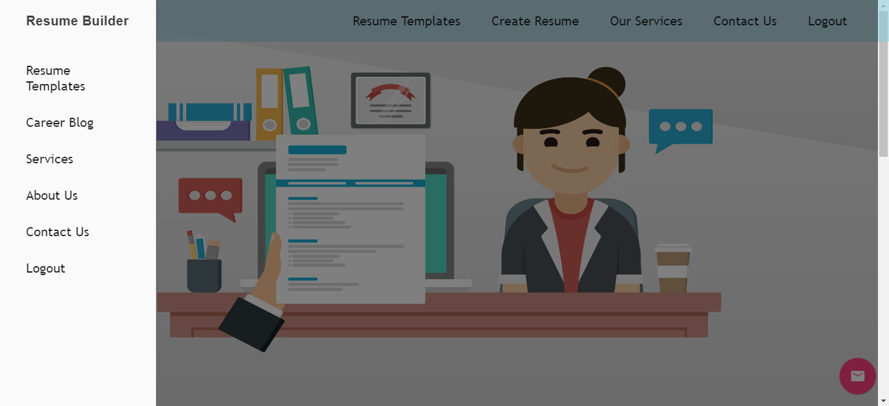

**Figure 16(Home_2)**

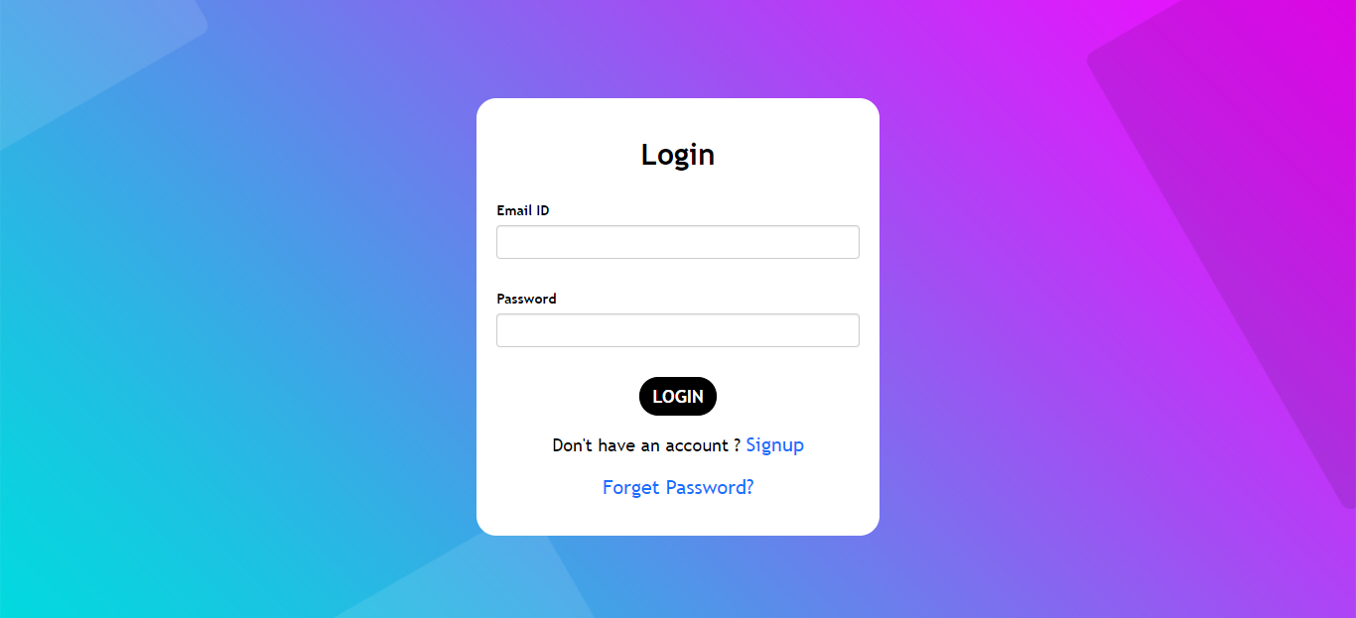

**Figure 17(Login)**

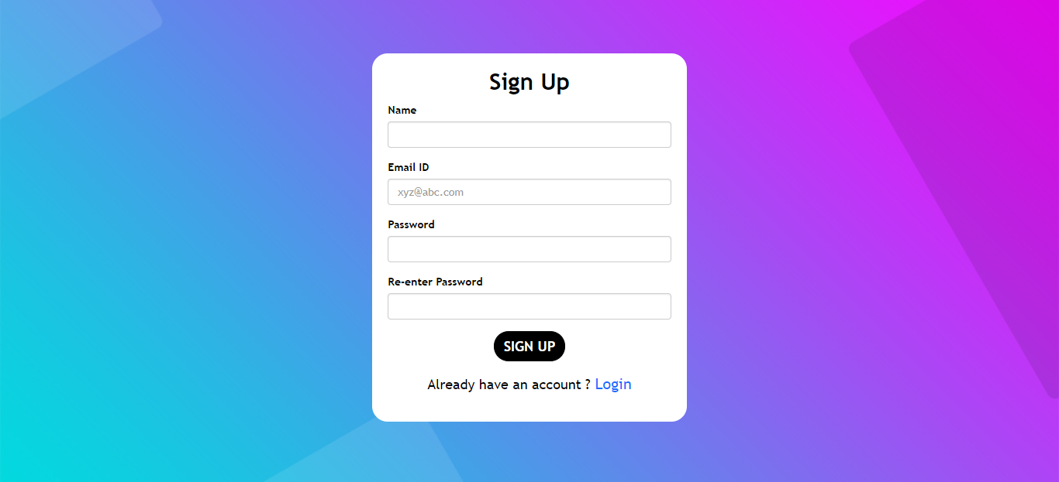

**Figure 18(Sign up)**



**Figure 19(Contact Form)**

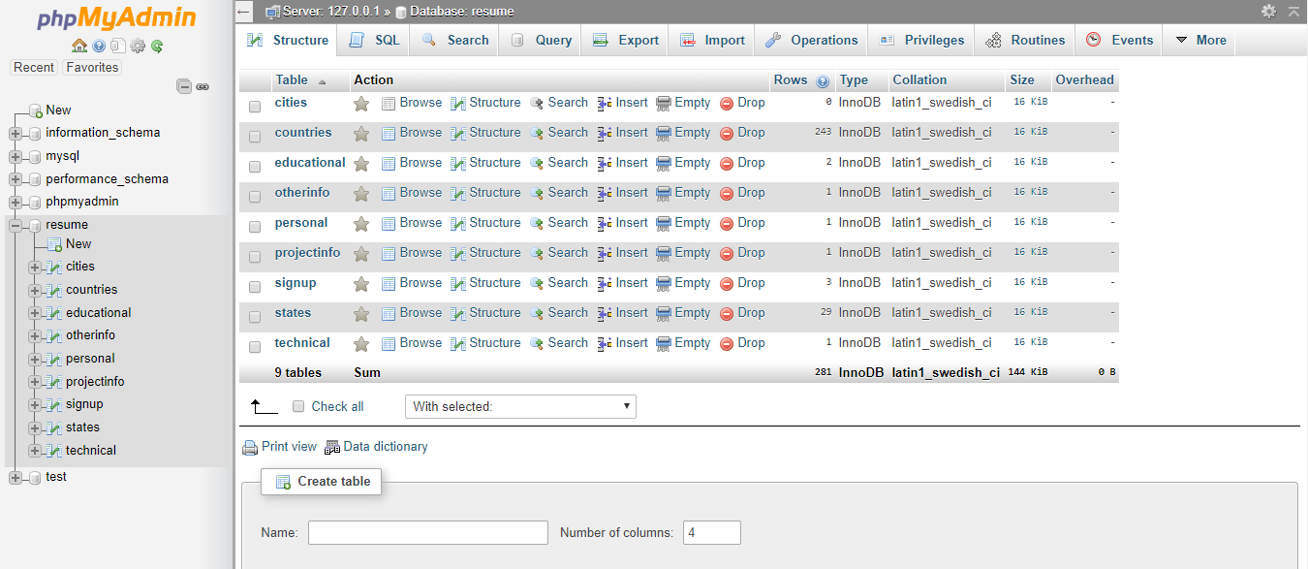

**Figure 20(Database)**

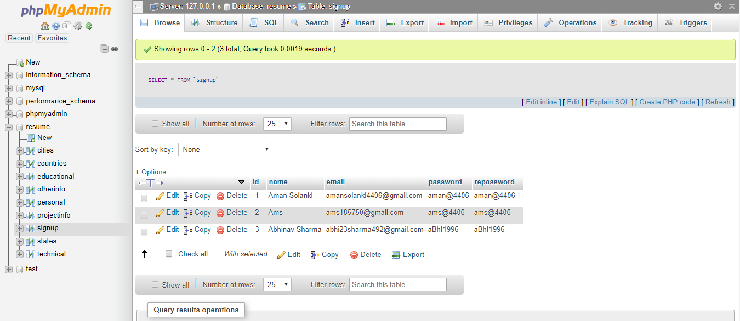

**Figure 21(Signup Table)**

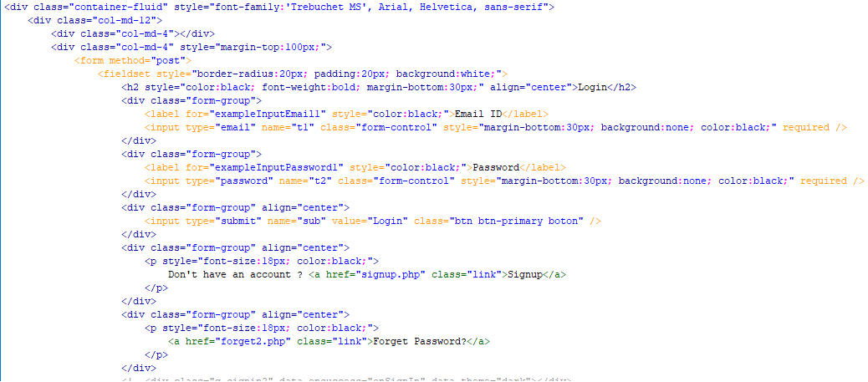

**Figure 22(Login Front end)**

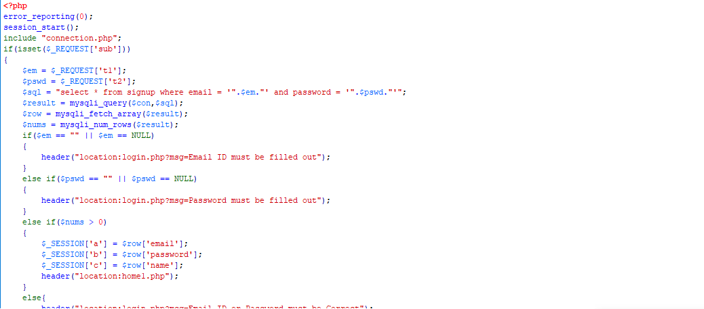

**Figure 23(Login Backend)**

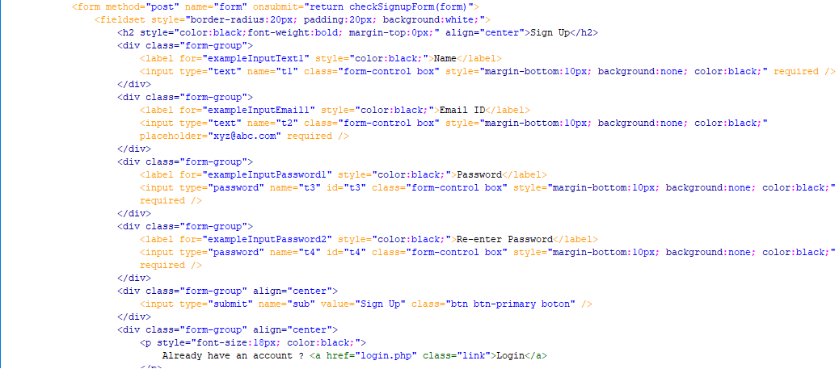

**Figure 24(Sign up Frontend)**

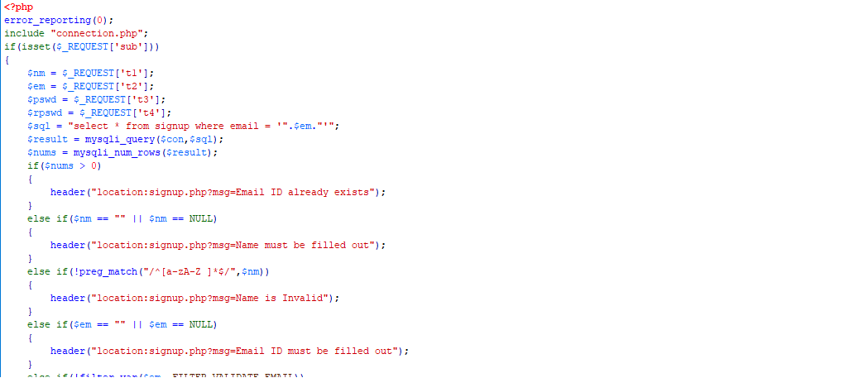

**Figure 25(Signup backend)**

## Sprint Backlog-2

**Figure 26(Create Resume)**

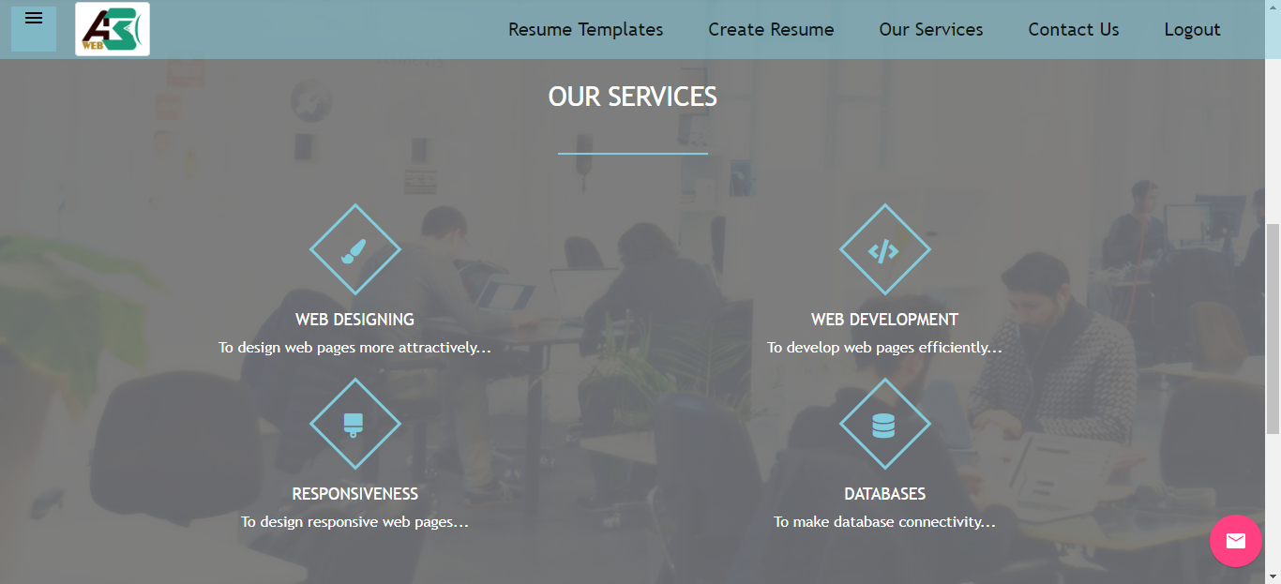

**Figure 27 (Services)**

## 

**Figure 28(Personal Info)**

## 

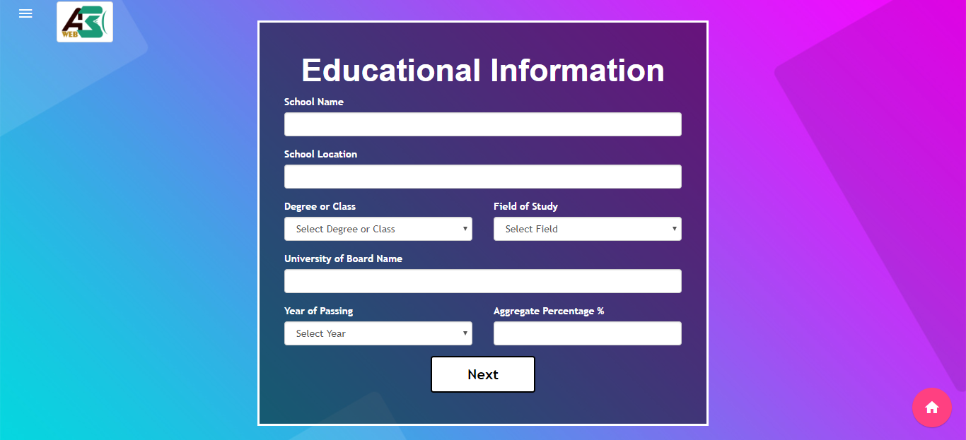

**Figure 29(Educational Info)**

## 

**Figure 30(Project Info.)**

## 

**Figure 31(Other_info Table)**

## 

## 

**Figure 32(Educational_info Table)**

## 

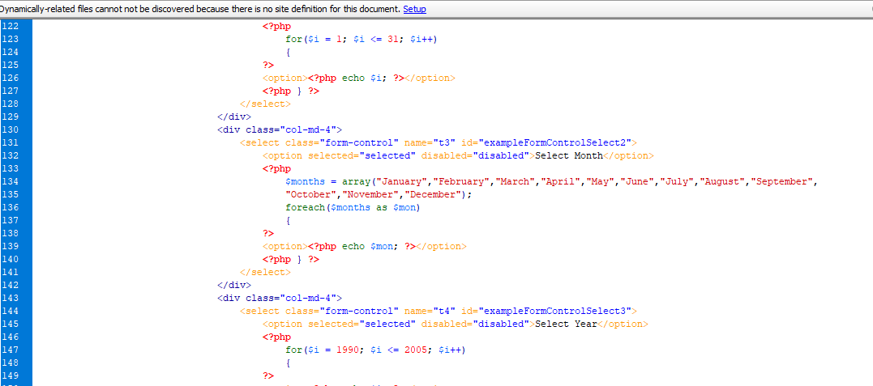

**Figure 33(Others_info Frontend)**

## 

**Figure 34(Educational_info Frontend)**

## 

## Sprint Backlog-3

## 

## Figure 35(Other details)

## 

## 

## Figure 36(Technical Details)

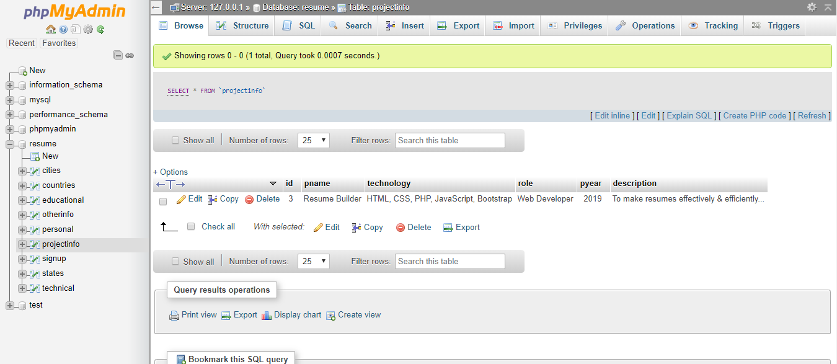

**Figure 37(Project_info Table)**

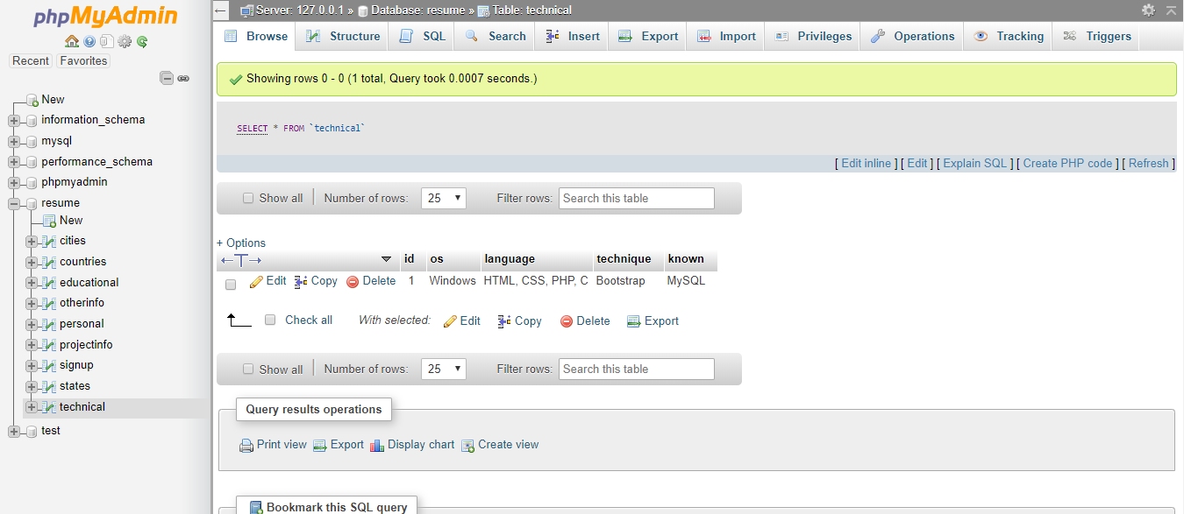

**Figure 38(Technical Table)**

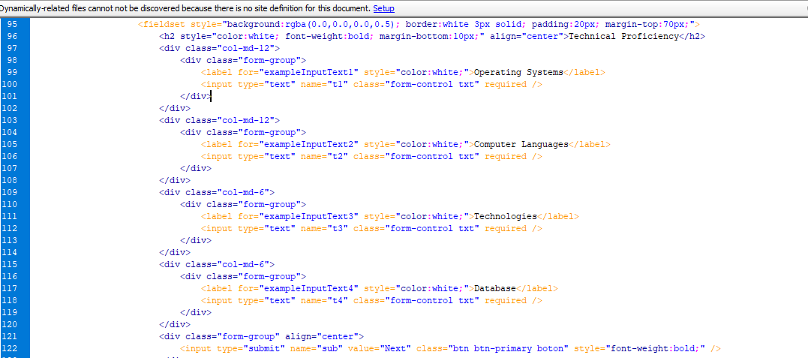

**Figure 39(Technical Frontend)**



**Figure 40(Others Frontend)**

**Sprint backlog-4**

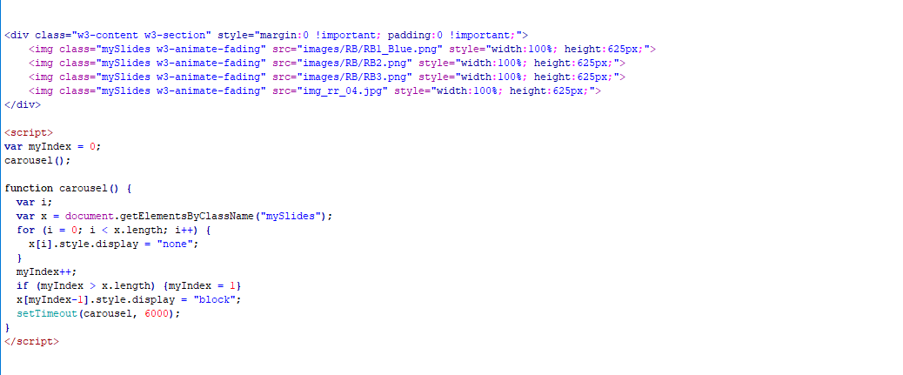

**Figure 41(Home Slider)**



**Figure 42(Contact Button)**



**Figure 43(Ready)**

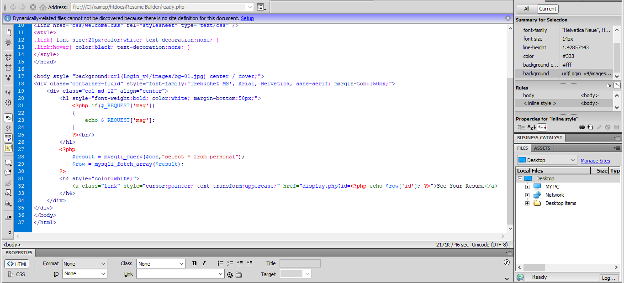

**Figure 44(Ready_code)**

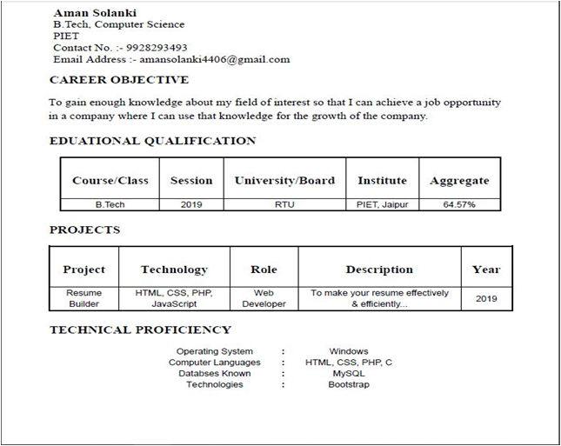

**Figure 45(Resume)**

# CHAPTER 5

# CONCLUSION

## Results:

## The user is able to make his resume successfully.

## The user can make his resume from various templates.

## Conclusion & Future Scope:

1. The conclusion of the project is that the user can make the resume freely as per his/her choice.
2. Resume will always be used by the fresher. So this project future scope is high.
3. For our college student also we have made a template according to the type of format which was provided by our college to us.